School of Education

EDUC7602 Numeracy Across
the Curriculum

Professional Experience
Handbook 2021

© The University of Queensland 2021

Last Update 10/01/20
Page 1

EDUC7602 – Numeracy across the curriculum Master of Teaching (Secondary)
Field Experience (observation only) 5 single days

Thank you for participating in this 5 day field experience component for the Master of Teaching (Secondary) program. The University is extremely grateful to those schools and teachers who are actively involved in mentoring and supporting our preservice teachers during their professional experience. We appreciate the ways in which practical experience in a school setting provides our students with the opportunity to expand both breadth and depth of experience.

The Master of Teaching (Secondary) Overview

The Master of Teaching (Secondary) is a postgraduate teacher preparation program meeting the Queensland College of Teachers requirements for entry into secondary teaching. The program requires two years of full-time study or part time equivalent, and consists of periods of on-campus lectures, tutorials and workshops, alternated with blocks of professional placements in schools.

The preservice teachers in this Master of Teaching (Secondary) cohort come from a variety of backgrounds and all are graduates of bachelor degrees. Some have completed an undergraduate degree directly after completing their schooling and have continued on to the Master of Teaching (Secondary). Others have entered the program with a variety of undergraduate and postgraduate education and work experience.

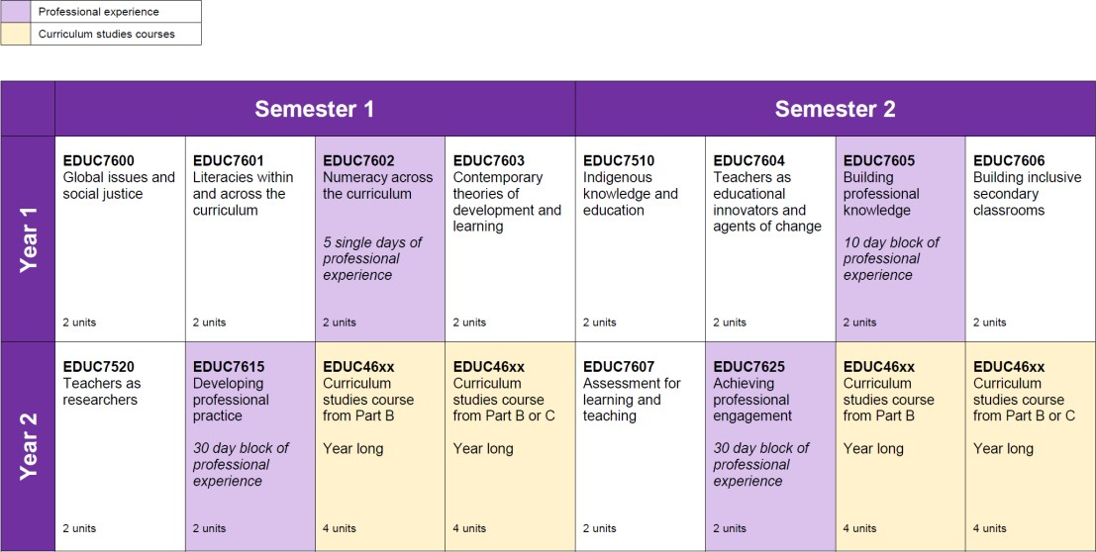
Program snapshot

The Developmental Continuum for Professional Experience
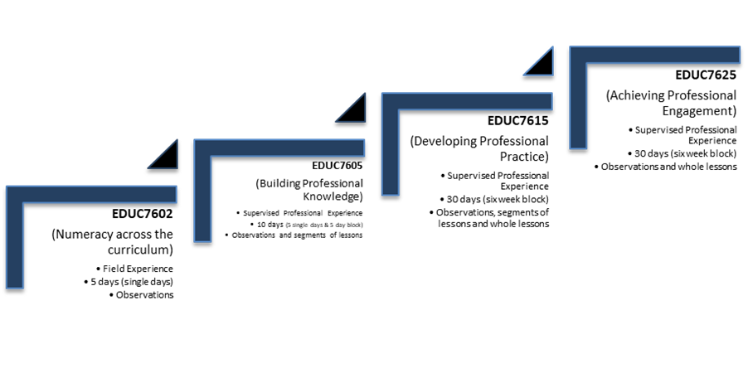
IMPORTANT DATES

EDUC7602 – Numeracy Across the Curriculum

Duration: Dates: AND

5 single days (1 day per week – Friday*)
Single days: Friday 23 Apr, Friday 30 Apr, Friday 07 May, Friday 14 May and Friday 21 May 2021

Event | Date/s | Notes
Professional experience preparation | Approx. 2 week prior to first day of placement. | Preservice teacher makes contact with the professional experience school.
5 single days of Professional experience  (Fridays – unless negotiated otherwise) | Friday 23 Apr  Friday 30 Apr  Friday 07 May  Friday 14 May  Friday 21 May | Observational and assist the classroom teacher to provide learning support with direction.
Attendance Sheet  Preservice teacher to submit to course coordinator. | Friday 21 May or after any makeup days if required- | Attendance sheet to be completed after each day of placement to be finalised and signed by preservice teacher, supervisor and school coordinator. Preservice teacher to submit to UQ academic staff.
Pay claim forms | To be submitted once the placement block has been completed | Supervising teacher and school coordinator complete pay claim forms. The Coordinator signs and emails the pay claims to UQ.

*unless negotiated otherwise

Further information on EDUC7602 can be found here https://education.uq.edu.au/numeracy-across- curriculum.

EDUC7602 – Aims and Objectives
Students are to observe numeracy moments and opportunities across the curriculum in secondary classrooms.

- It is critical to get preservice teachers into schools early in their program
- Allows preservice teachers to experience first-hand the connections between theory and practice
- Introduces preservice teachers gradually into school life and teaching before they start officially planning and teaching (requirements, expectations, duties & responsibilities)
- Encourages critical thinking and reflection from the start of their program
- Is the first step in developing a professional identity as a teacher.

Observation of lessons

Students are required to observe lessons and to make notes on these observations.

The observation periods are as important as the teaching periods; they will ensure that students experience a wide range of learning situations and interactions with varying age groups.

Students should discuss salient aspects of the lesson observed with their teacher.

Apart from observations of lessons given by school staff, students should make general observations of as many aspects of the life of the school as possible.

Classroom observations are intended to develop understanding of:

- Student learning
- A range of teaching strategies and the way in which these are varied to suit the context and the student group
- The skills and techniques required for effective communication
- The relationship between long and short-term planning and successful practice
- The roles monitoring and assessment play in teaching and learning.

Field Experience Policies and Procedures

Preservice teachers are required to undertake field experience consisting of 5 full day visits to a school allocated by the University.

Weekly visits will take place on Fridays unless negotiated otherwise. Students can observe in pairs (not essential). Any teaching areas are appropriate.

100% attendance is mandatory. Any missed days must be made up.

It is a requirement for each course that contains a field experience component that every preservice teacher signs and lodges a statement that they have read the Policies and Procedures for Professional Experience before being permitted to undertake ANY professional experience. Failure to sign this document may prevent preservice teachers from receiving a placement. This is monitored by the course coordinator and the Policies and Procedures for Professional Experience document can be viewed here https://education.uq.edu.au/current-students/professional-experience

Supervising teachers and course coordinators will also be required to sign off on the preservice teacher’s ‘attendance sheet’ to record the 5 single days attended as part of the professional experience.

Preservice teachers can be expected to attend the school outside of regular school hours if required.

Preservice teachers will be expected to participate in school life to the fullest extent. They will attend any meetings held during the time of the practicum, e.g. year level or whole of staff meetings, any professional development meetings where attendance is approved by the school and participate in extracurricular activities etc. available during the block.

IMPORTANT: For the period of any supervised teaching practice, preservice teachers cannot take sole responsibility for the oversight of students and must ensure that they are in the company of their supervisor or another registered teacher in any location when students are in their care.

Roles and Responsibilities

Preservice Teachers’ Roles and Responsibilities

The following notes are taken from the Policies and Procedures for Professional Experience document given to preservice teachers prior to commencement of any in-school professional experience. It can be viewed here https://education.uq.edu.au/current-students/professional-experience.

Commencement of the professional experience - Orientation, Observation and Planning

The orientation, observation and planning period at the start of each professional experience placement provides preservice teachers with an introduction to the context of the school and the classroom. During this period of time preservice teachers will:
- Upon receiving their placement information, make immediate contact with the school coordinator to organise arrival/orientation/induction etc.
- Meet school staff and the classes they will observe.
- Begin the structured observations they will continue throughout the professional experience.
- Ensure that they are familiar with school policies including those on occupational health and safety and child protection.
- Familiarise themselves with the school layout, timetable and their own timetable.
- Note times and dates for any particular events such as staff meetings they should attend.
- Assist in the classroom in any way suited to their experience.

Preservice teacher’s relationships with school-based supervisors

As a preservice teacher you are a guest in the school and, although you cannot legally assume the full responsibilities of a qualified teacher, you are regarded as a temporary staff member, responsible to the principal. You are required to consult with your school-based personnel, and particularly your supervising teacher, as frequently as possible. The supervising teachers are ready to help, but their time is limited and it is your responsibility to find a time to meet within their other commitments.

While in the school you must work in partnership with other teachers, professionals, teacher aides and other relevant adults and perform any duties or tasks in a manner that is consistent with the policies and procedures of the employing authority and school, and the legal and ethical obligations of teachers. Experimentation with a variety of teaching methods is encouraged, but the class remains the supervising teacher’s responsibility throughout the professional experience, and their advice on what is suitable or practical for the class should be sought and followed.

Preservice teacher’s relationships with school students

The kind of relationship with students to strive for is one based on mutual respect. This can be fostered by quickly learning the names of the students you teach, treating them with courtesy, and maintaining a high level of interest in their progress and in your teaching. You should quickly discover the interests and academic strengths and weaknesses of your students. You should require courtesy and firmly insist on considerate behaviour from them towards you and all others. You should identify and know how to apply school procedures with regard to behaviour management and student safety.

Preservice teacher’s participation in general school activities

Preservice teachers are expected to assist with playground supervision, sports supervision, and other work as requested by school-based personnel during professional experience/field experience. However, while involvement in a wide range of teaching situations is a valuable part of professional experience, preservice teachers cannot legally take sole charge of school students.

Opportunities for observation and/or participation could be:
- Attendance at staff or faculty meetings
- Involvement in co-curricular activities
- Attendance at school excursions or formal school occasions
- Attendance at professional development activities

Professionalism

The School of Education expects that preservice teachers will demonstrate a professional manner by:

- adhering to the QCT’s ‘Code of Ethics for Teachers in Queensland’ found here https://www.qct.edu.au/standards-and-conduct/code-of-ethics
- complying with statutory requirements, in particular with those involving occupational health and safety and child protection. Please speak to your course coordinator for further information.
- maintaining confidentiality and discussing these matters if needed ONLY with the appropriate staff within the School of Education and/or the host school
- respecting the ethos of the host school
- understanding that you are a guest of the host school and you must follow the direction of the Principal or other designated staff
- understanding the role of the supervising teacher as a supervisor and mentor.
- participating fully in the role of a teacher on the days of attendance. Please refer to section addressing the ‘attendance policy’
- adhering to any dress or conduct codes
- using appropriate language at all times
- not using your mobile phone at all during your professional experience while at your host school, unless under exceptional circumstances
- complying with all other instructions from the host school and UQ staff
- completing all designated tasks according to deadlines and requirements. When observing a class and making notes, these must not be judgmental, as you are not assessing performance. You do not yet have the professional knowledge or experience to do that.
- restricting the scope of the observation to the focus area given to you by the course coordinator or as discussed with your supervising teacher

Non-compliance with a directive from School of Education or placement school staff may result in a placement being withdrawn. In this instance, you may be required to withdraw from the UQ course with the placement component and if so, you may incur academic penalty or financial liability. You will also be required to complete the course in full in a future semester.

Concerns regarding professionalism:

The School of Education must be notified immediately in any case where the preservice teacher has failed to:
  - Comply with the school’s policy for the protection of young people.
  - Comply with the school’s policy on occupational health and safety.
  - Comply with any lawful direction given by school supervising staff.
  - Act in a professional manner.
  - Meet attendance requirements.

Attendance

Supervising teachers and course coordinators will be required to sign off on the preservice teacher’s ‘attendance sheet’ to record the 5 single days attended as part of the professional experience.

The School of Education expects preservice teachers to:
  - check the School of Education Professional Experience Calendar found on the School of Education webpage > current students > professional experience https://education.uq.edu.au/current-students/professional-experience-information
  - check their timetable in MyTimetable to ensure they are available to attend the placement as scheduled
  - be punctual in attendance on all placement days
  - arrive/leave the placement in accordance with placement school policy and the requirements of tasks on the particular day. This will include allowing time for discussions with your supervising teacher or other members of the school staff involved in your placement. As a guideline, you should expect to be at the placement school between 8am and 4pm or as otherwise required by the placement school administration. You may be required to complete lesson preparation and marking outside of these hours, as well as attend before or after school meetings

  - report, in the case of absence through illness, to the placement school and follow all relevant procedures in relation to providing any necessary documentation or lesson plans if required. You must also notify the School of Education in writing of the absence and the make-up days negotiated with the school
  - provide the School of Education with a medical certificate for absences greater than 3 consecutive days. The placement school may request a certificate for less than 3 days as part of the school’s absentee procedure
  - refrain from leaving early, or display any general lack of punctuality for work/study/social related reasons
  - make immediate contact with the school coordinator and provide a detailed explanation of the issue to your placement facilitator by email in the case of any serious problems arising. In the absence of a placement facilitator (ie for single day field experience observations) please contact the course coordinator
  - make up any days missed due to illness or public holidays etc except those preservice teachers who have a public holiday fall during a multiple week-long professional experience ‘block’. Make up days are not required in this instance. In the case of single day field experience placements, ensure you schedule your university timetable to avoid placement days clashing with other classes. Alternative placement days cannot be negotiated for personal commitments such as work, sport, or social commitments
  - to request to attend on an alternate day if you have an unavoidable timetable clash with your scheduled placement day please contact the School of Education placements team education@uq.edu.au
  - understand that alternative commencement/completion dates for multiple week-long professional experience ‘blocks’ are not permitted to be changed without prior approval of the Program Director, the School of Education and relevant placement school. Alternative dates will not be approved for work, sport or social commitments unless there is evidence of extenuating circumstances
  - realise that if you do not meet the attendance requirements of your professional experience, you may have your professional experience withdrawn. If it is decided the placement needs to be withdrawn, you may also be required to withdraw from the relevant UQ course and will incur any financial liabilities or academic penalties.

Roles and Responsibilities of host school personnel:
The personnel involved are the school coordinator of preservice teachers, the supervising teacher and any other school personnel who take a role in professional experience/field experience supervision of preservice teachers. The roles and responsibilities outlined below are generic and may be undertaken by other personnel as appropriate.

The school coordinator of preservice teachers

The school coordinator of preservice teachers oversees the professional experience within the school.

The school coordinator (or delegate) must induct (e.g. site induction, emergency procedures, incident hazard reporting mechanisms) the preservice teacher into the school’s Occupational Health and Safety policy and discuss the ways in which the various aspects of the policy will affect the preservice teacher during the professional experience. Where possible the preservice teacher should be supplied with a copy of the policy. The preservice teacher will complete an OHS risk assessment questionnaire based on this induction.

The school coordinator organises supervision and teaching timetables for preservice teachers.

The school coordinator may arrange meetings with the preservice teachers, at which advice and information may be given on organisational aspects of the school. Some suggested discussion items include: types of student records, assessment procedures, work programs, school report forms, discipline, parent and community relations, finance, teaching aids, library facilities and staff committees.

The school coordinator may also arrange for the preservice teachers to confer with key members of the staff, such as the teacher librarian or guidance counsellors to provide preservice teachers with insight into other facets of the life of the school community.

The school coordinator may make arrangements for preservice teachers to engage in non-classroom experiences such as assisting teachers with playground supervision and may encourage preservice teachers to take part in extra-curricular school activities.

The preservice teacher should be told of any policies re the availability and use of ICT and photocopiers.

The supervising teacher

The supervising teacher has a key role in the professional preparation of future teaching colleagues by offering close tutorial assistance, support and evaluative advice over the professional experience period.

We require that supervising teachers:
  - Are recommended/identified as a suitable mentor by the Principal/Deputy Principal/Head of Department/Lead Teacher
  - Have a genuine interest in helping to support, guide and mentor preservice teachers
  - Understand and appreciate that working with preservice teachers is a mutually beneficial experience

We request that supervising teachers offer the following guidance to preservice teachers. This statement is based on the Agreement on Teaching Practice negotiated by the Teachers’ Unions and Universities.
  - During the first day of the placement, discuss an appropriate pattern of observations and teaching with the preservice teacher.
  - Provide induction on school policies and procedures particularly OH&S and Child Protection policies (this may also include providing Safe Operating Procedures for classes in labs).
  - Provide guidance on class management procedures and on the broader school policies and procedures.
  - Provide a wide range of observation situations.
  - Provide guidance on overall development as a teacher.

Concerns regarding preservice teacher performance

At any stage of the supervised professional experience, if there are any concerns about the demonstrated performance of a preservice teacher the University should be contacted immediately.

In the first instance, contact the School of Education Placements Team on 3365 6550 or email education@uq.edu.au.

In these few cases where host school staff personnel have concerns, it is critical that the process required under the University of Queensland Policies and Procedures for Placements is followed.

Pay claims

Further information can be found here https://education.uq.edu.au/prac-pay-claims

Contact the School of Education

Contact details can be found here https://education.uq.edu.au/contact

